Packet Tracer - Explore a Network

1. Topology

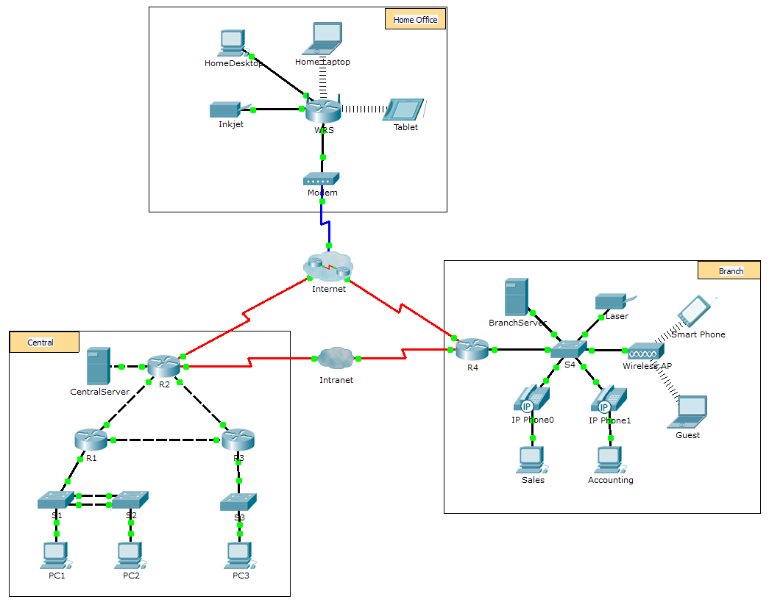

1. Objectives

Part 1: Examine Internetwork Traffic at Branch

Part 2: Examine Internetwork Traffic to Central

Part 3: Examine Internet Traffic from Branch

1. Background

This simulation activity is intended to help you understand the flow of traffic and the contents of data packets as they traverse a complex network. Communications will be examined at three different locations simulating typical business and home networks.

Take a few moments to study the topology displayed. The Central location has three routers and multiple networks possibly representing different buildings within a campus. The Branch location has only one router with a connection to both the Internet and a dedicated wide-area network (WAN) connection to the Central location. The Home Office makes use of a cable modem broadband connection to provide access to both the Internet and to corporate resources over the Internet.

The devices at each location use a combination of static and dynamic addressing. The devices are configured with default gateways and Domain Name System (DNS) information, as appropriate.

1. Examine Internetwork Traffic at Branch

In Part 1 of this activity, you will use Simulation mode to generate web traffic and examine the HTTP protocol along with other protocols necessary for communications.

* 1. Switching from Realtime to Simulation mode.
     1. Click the **Simulation** mode icon to switch from **Realtime** mode to **Simulation** mode.
     2. Verify that **ARP, DNS, HTTP**,and **TCP** are selected from the **Event List Filters**.
     3. Move the slider located below the **Play Controls** buttons (**Back**, **Auto Capture**/**Play**, **Capture**/**Forward**) all the way to the right.
  2. Generate traffic using a web browser.

Currently the Simulation Panel is empty. In the Event List at the top of the Simulation Panel there are six columns listed across the heading. As traffic is generated and stepped through, events display in the list. The **Info** column is used to inspect the contents of a particular event.

**Note**: The panel to the left of the Simulation Panel displays the topology. Use the scrollbars to bring the Branch location into the panel, if necessary. The panels can be adjusted in size by hovering next to the scrollbar and dragging left or right.

* + 1. Click the **Sales PC** in the far left pane.
    2. Click the **Desktop** tab and click the **Web Browser** icon to open it.
    3. In the URL field, enter **http://branchserver.pt.pta** and click **Go**. Look in the Event List in the Simulation Panel. What is the first type of event listed?

____________________________________________________________________________________

* + 1. Click the **DNS** info box. In the **Out Layers**, DNS is listed for Layer 7. Layer 4 is using UDP to contact the DNS server on port 53 (**Dst Port:**). Both the source and destination IP addresses are listed. What information is missing to communicate with the DNS server?

____________________________________________________________________________________

* + 1. Click **Auto Capture/Play**. In approximately 30 to 40 seconds, a window displays, indicating the completion of the current simulation. (Or a window may display indicating that the buffer is full.) Click the **View Previous Events** button. Scroll back to the top of the list and note the number of **ARP** events. Looking at the Device column in Event list, how many of the devices in the Branch location does the **ARP** request pass through?

____________________________________________________________________________________

* + 1. Scroll down the events in the list to the series of **DNS** events. Select the **DNS** event that has the “At Device” listed as **BranchServer**. Click the square box in the **Info** column. What can be determined by selecting Layer 7 in the **OSI Model**? (Look at the results displayed directly below **In Layers.**)

____________________________________________________________________________________

* + 1. Click the **Outbound PDU Details** tab. Scroll to the bottom of the window and locate the DNS Answer section. What is the address displayed?

____________________________________________________________________________________

* + 1. The next several events are **TCP** events enabling a communications channel to be established. Select the last **TCP** event at device **Sales** just prior to the **HTTP** event. Click the colored square Info box to display the PDU information. Highlight Layer 4 in the **In Layers** column. Looking at item 6 in the list directly below the **In Layers** column, what is the connection state?

____________________________________________________________________________________

* + 1. The next several events are **HTTP** events. Select any one of the **HTTP** events at an intermediary device (IP Phone or Switch). How many layers are active at one of these devices, and why?

____________________________________________________________________________________

* + 1. Select the last **HTTP** event at the Sales PC. Select the uppermost layer from the **OSI Model** tab. What is the result listed below the **In Layers** column?

____________________________________________________________________________________

1. Examine Internetwork Traffic to Central

In Part 2 of this activity, you will use Packet Tracer (PT) Simulation mode to view and examine how traffic leaving the local network is handled.

* 1. Set up for traffic capture to the Central web server.
     1. Close any open PDU Information windows.
     2. Click **Reset Simulation** (located near the middle of the Simulation Panel).
     3. Type **http://centralserver.pt.pta** in the web browser of the Sales PC.
     4. Click **Auto Capture/Play**; in approximately 75 seconds, a window displays, indicating the completion of the current simulation. Click **View Previous Events**. Scroll back to the top of the list; note that the first series of events are **DNS** and there are no **ARP** entries prior to contacting the **BranchServer**. Based on what you have learned so far, why is this the case?

____________________________________________________________________________________

* + 1. Click the last DNS event in the **Info** column. Select **Layer 7** in the **OSI Model** tab.

By looking at the information provided, what can be determined about the DNS results?

____________________________________________________________________________________

____________________________________________________________________________________

* + 1. Click the **Inbound PDU Details** tab. Scroll down to the **DNS ANSWER** section. What is the address listed for centralserver.pt.pta?

____________________________________________________________________________________

* + 1. The next several events are **ARP** events. Click the colored square Info box of the last **ARP** event. Click the **Inbound PDU Details** tab and note the MAC address. Based on the information in the ARP section, what device is providing the ARP reply?

____________________________________________________________________________________

* + 1. The next several events are **TCP** events, once again preparing to set up a communications channel. Find the first **HTTP** event in the Event List. Click the colored square box of the **HTTP** event. Highlight Layer 2 in the **OSI Model** tab. What can be determined about the destination MAC address?

____________________________________________________________________________________

* + 1. Click the **HTTP** event at device **R4**. Notice that Layer 2 contains an Ethernet II header. Click the **HTTP** event at device **Intranet**. What is the Layer 2 listed at this device?

____________________________________________________________________________________

Notice that there are only two active layers, as opposed to three active layers when moving through the router. This is a WAN connection, which will be discussed in a later course.

1. Examine Internet Traffic from Branch

In Part 3 of this activity, you will clear the events and start a new web request that will make use of the Internet.

* 1. Set up for traffic capture to an Internet web server.
     1. Close any open PDU information windows.
     2. Click **Reset Simulation** near the middle of the Simulation Panel. Type **http://www.netacad.pta** in the web browser of the Sales PC.
     3. Click **Auto Capture/Play**; in approximately 75 seconds, a window displays, indicating the completion of the current simulation. Click **View Previous Events**. Scroll back to the top of the list; notice that the first series of events are **DNS**. What do you notice about the number of **DNS** events?

____________________________________________________________________________________

____________________________________________________________________________________

* + 1. Observe some of the devices that the **DNS** events travel through on the way to a DNS server. Where are these devices located?

____________________________________________________________________________________

____________________________________________________________________________________

* + 1. Click the last **DNS** event. Click the **Inbound PDU Details** tab and scroll down to the last DNS Answer section. What is the address listed for **www.netacad.pta**?

____________________________________________________________________________________

* + 1. When routers move the **HTTP** event through the network, there are three layers active in both the **In Layers** and **Out Layers** in the **OSI Model** tab. Based on that information, how many routers are passed through?

____________________________________________________________________________________

____________________________________________________________________________________

* + 1. Click the **TCP** event just prior to the last **HTTP** event. Based on the information displayed, what is the purpose of this event?

____________________________________________________________________________________

* + 1. There are several more **TCP** events listed. Locate the **TCP** event where the *Last Device* is **IP Phone** and the *Device At* is **Sales**. Click the colored square Info box and select **Layer 4** in the **OSI Model** tab. Based on the information from the output, what is the connection state set to?

____________________________________________________________________________________

1. Suggested Scoring Rubric

|  |  |  |  |
| --- | --- | --- | --- |
| Activity Section | Question Location | Possible Points | Earned Points |
| Part 1: Examine Internetwork Traffic at Branch | Step 2c | 5 |  |
| Step 2d | 5 |  |
| Step 2e | 5 |  |
| Step 2f | 5 |  |
| Step 2g | 5 |  |
| Step 2h | 5 |  |
| Step 2i | 5 |  |
| Step 2j | 5 |  |
| **Part 1 Total** | | **40** |  |
| Part 2: Examine Internetwork Traffic to Central | Step 1c | 5 |  |
| Step 1d | 5 |  |
| Step 1e | 5 |  |
| Step 1f | 5 |  |
| Step 1g | 5 |  |
| Step 1h | 5 |  |
| **Part 2 Total** | | **30** |  |
| Part 3: Examine Internet Traffic from Branch | Step 1c | 5 |  |
| Step 1d | 5 |  |
| Step 1e | 5 |  |
| Step 1f | 5 |  |
| Step 1g | 5 |  |
| Step 1h | 5 |  |
| **Part 3 Total** | | **30** |  |
| **Total Score** | | **100** |  |